**Week 1**

**Building a Foundation**

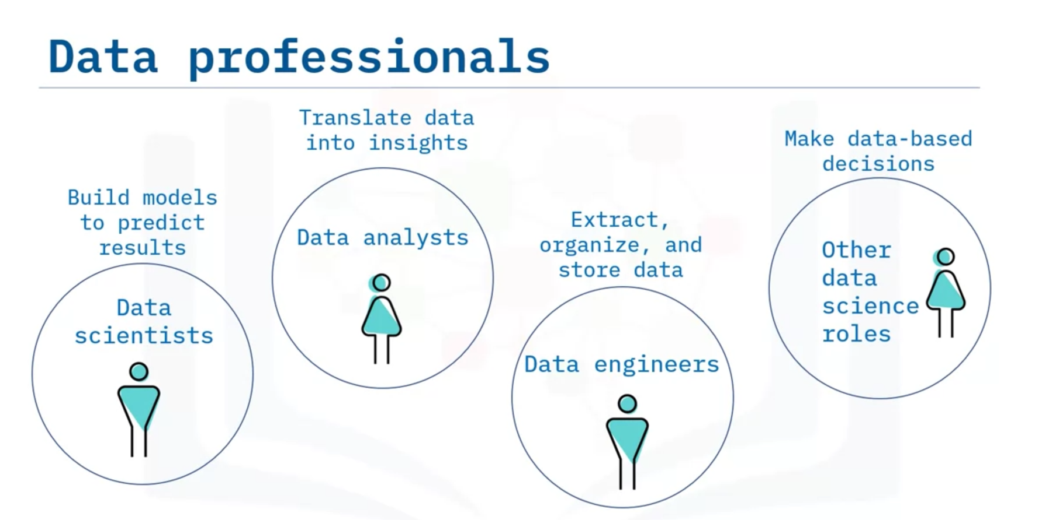

* **Data scientists** analyze data for actionable insights and build machine learning or deep learning models that can train on past data to create predictive models.
* **Data analysts** translate data and numbers into plain language. Data analysts also mine data and visualize it to interpret and present their findings.
* **Data engineers** extract and organize data from different sources, clean and prepare it, and then store and manage it in data repositories so that other data professionals can access it.
* There are other data professionals in the ecosystem too, such as **business analysts** and **business intelligence analysts**, who make decisions based on the data results.

Regardless of the roles and job titles, data science professionals generally work collaboratively to extract the data needed to identify trends or correlations and make predictions.

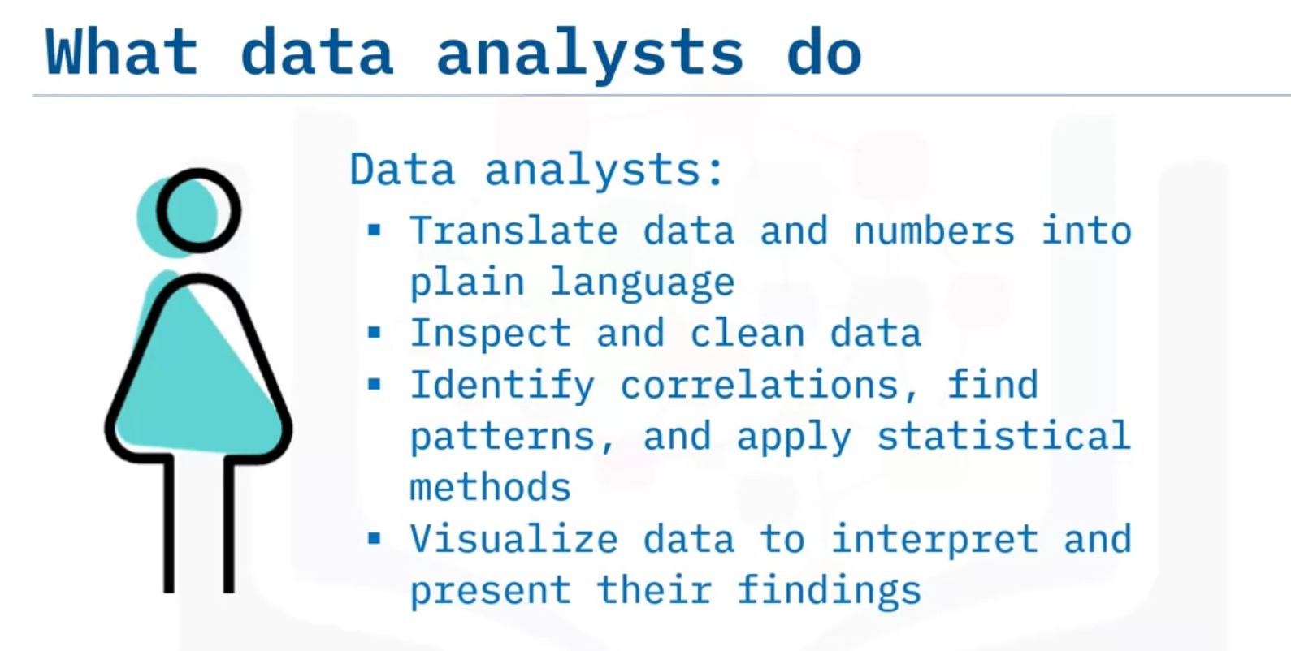

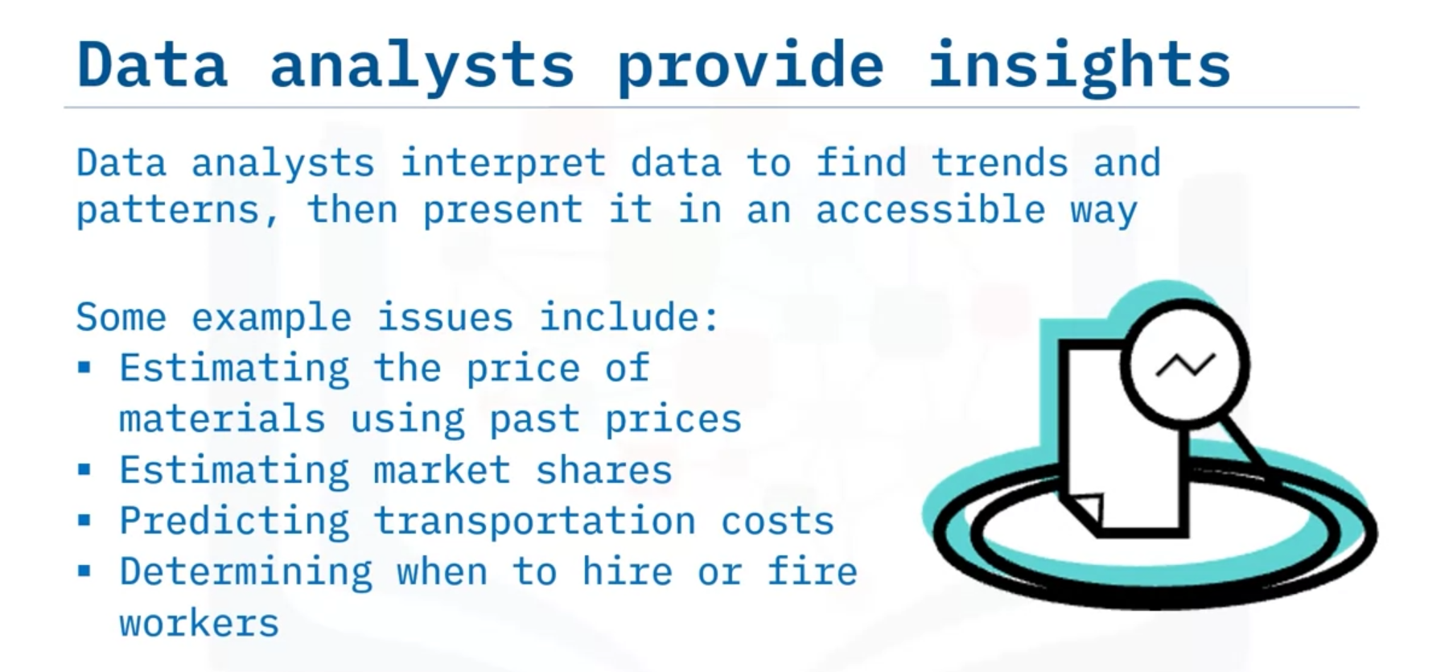

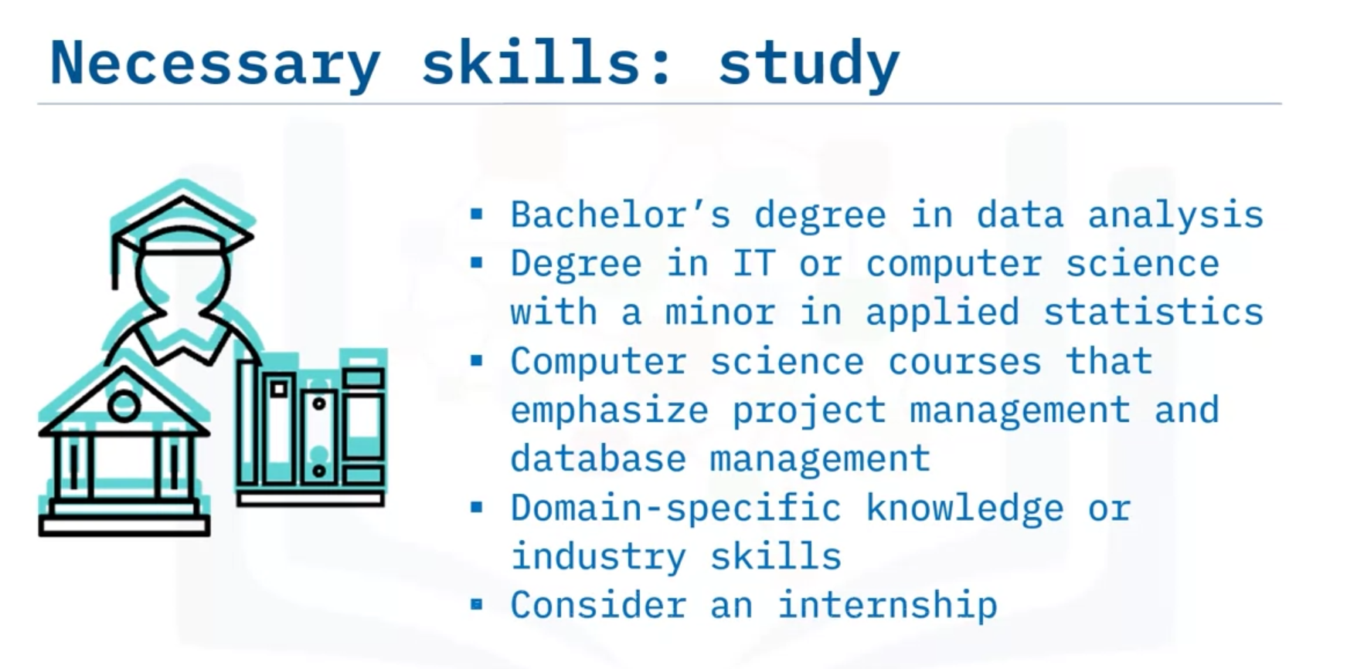

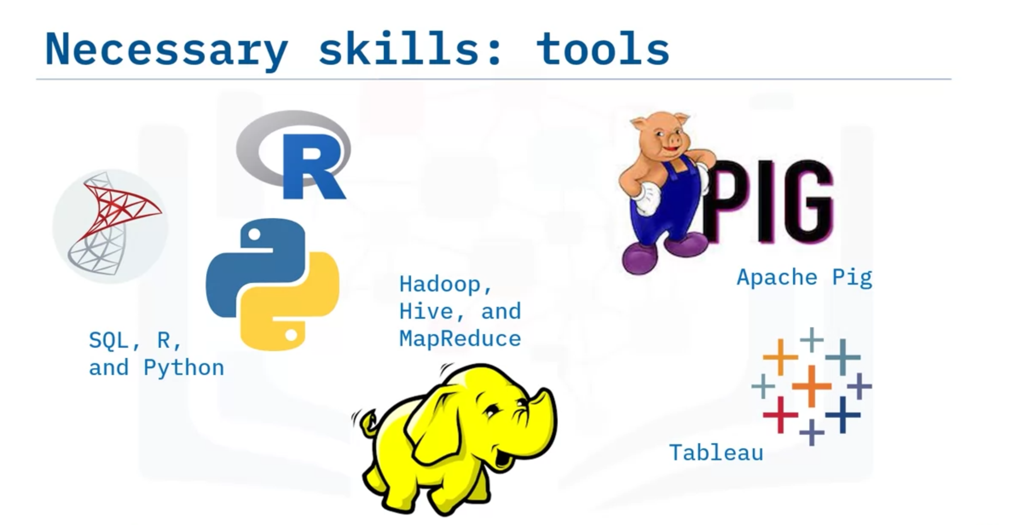

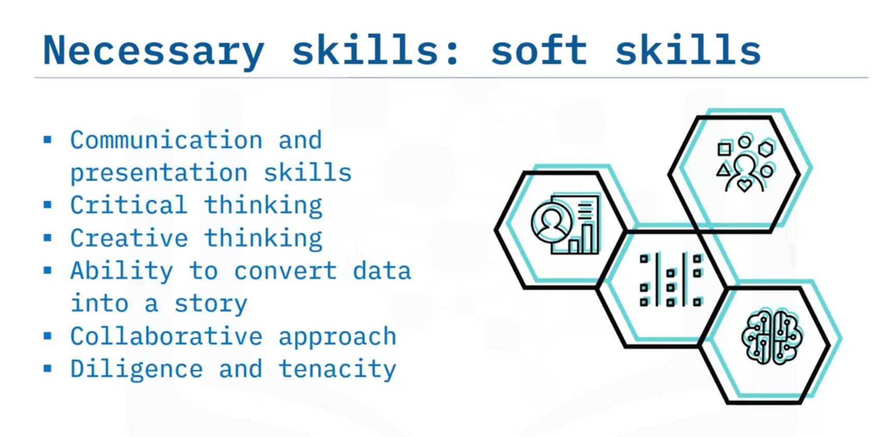

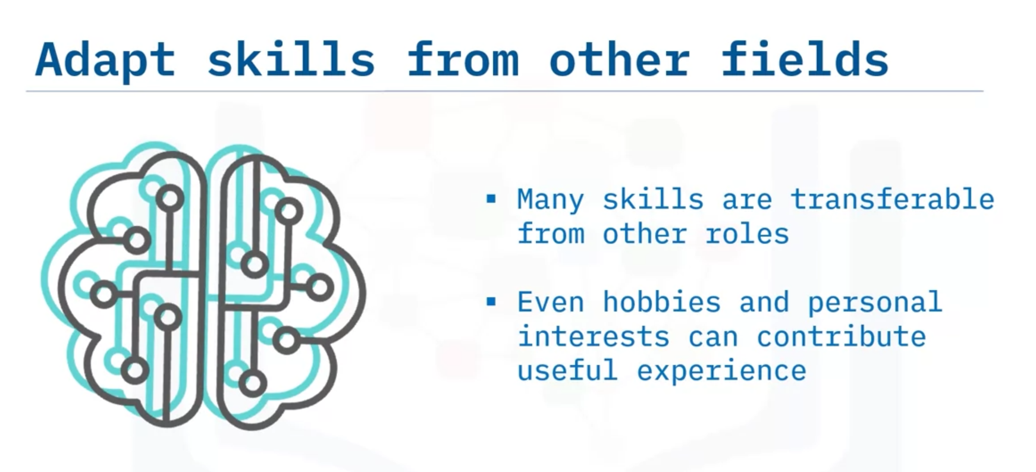

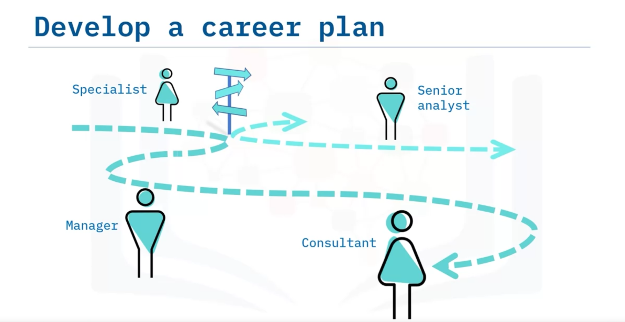

From the beginning or as you gain experience as a data analyst, you may advance your career in several different directions. Depending on your goals and interests, you may progress into becoming a specialist in some aspect of data analysis like social media, advancing your technical skills in programming or deeper data analysis, becoming a manager for a data analytics team, or going into business as a consultant, to name only a few.

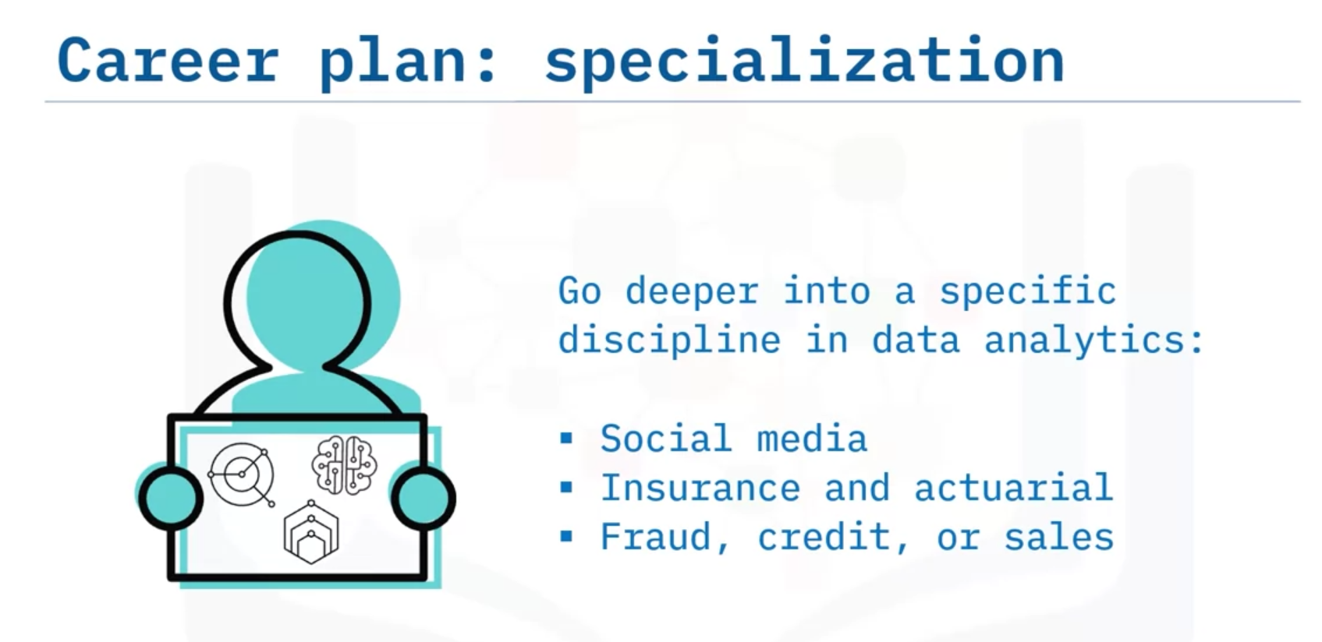

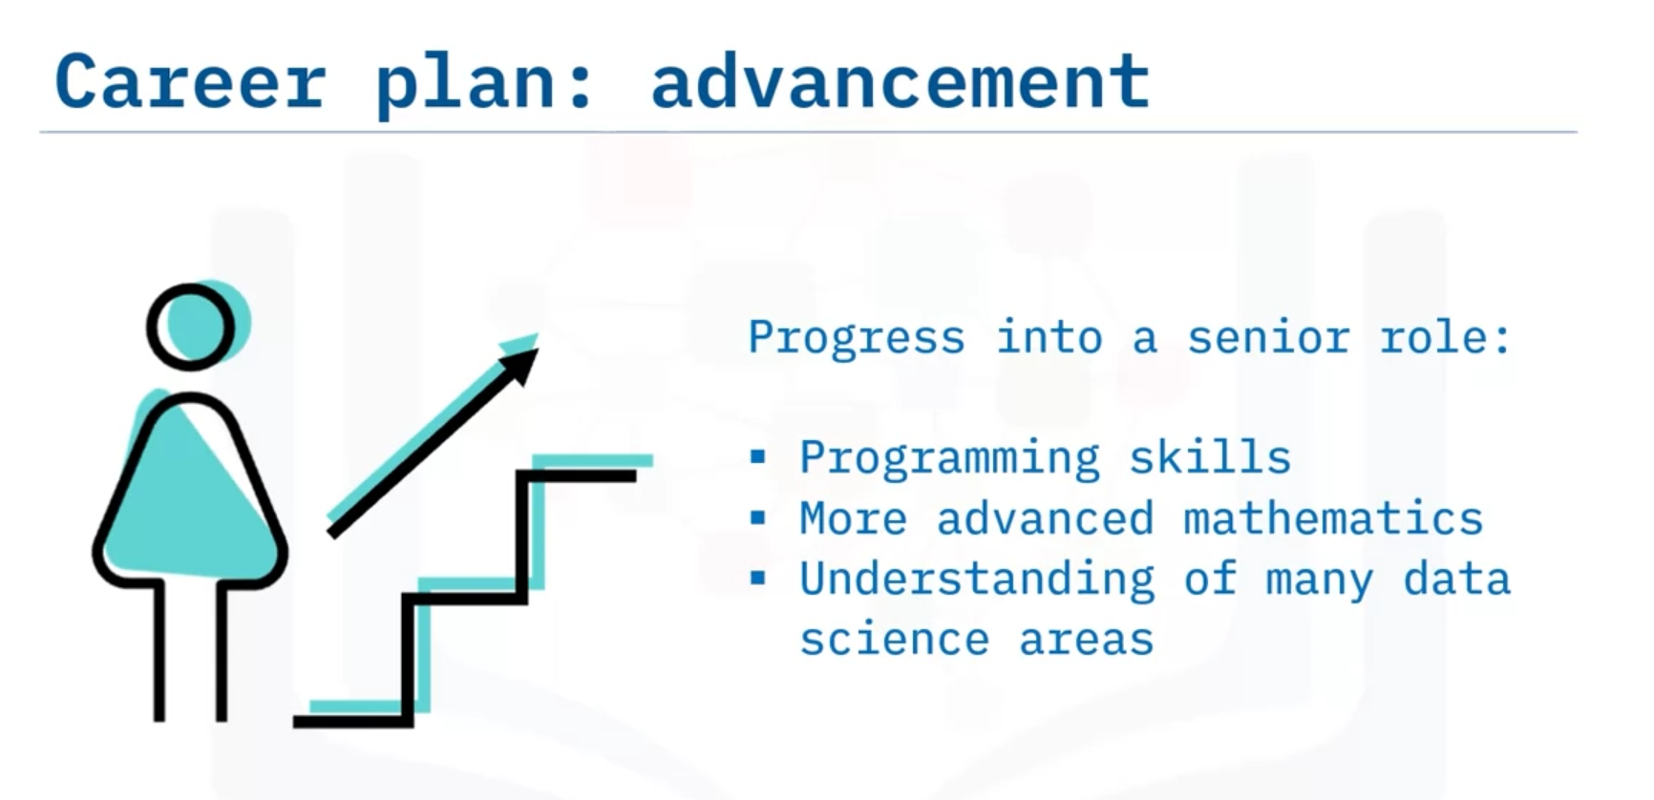

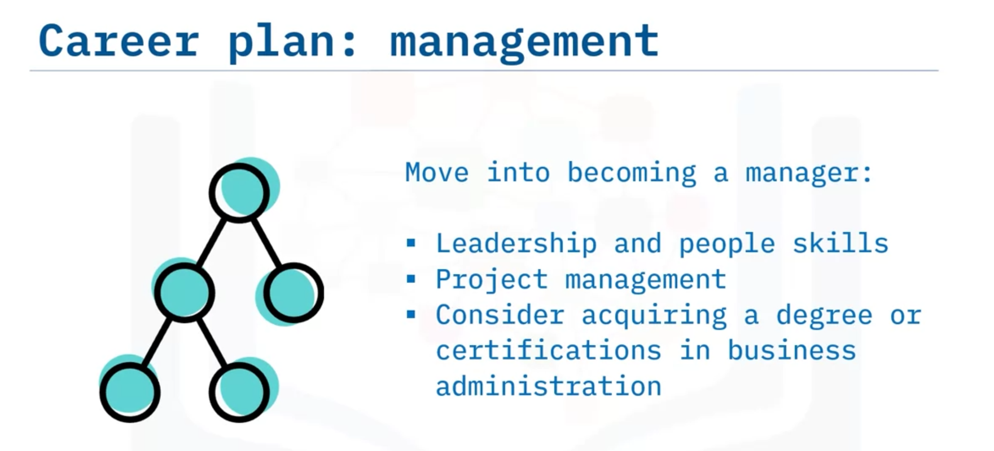

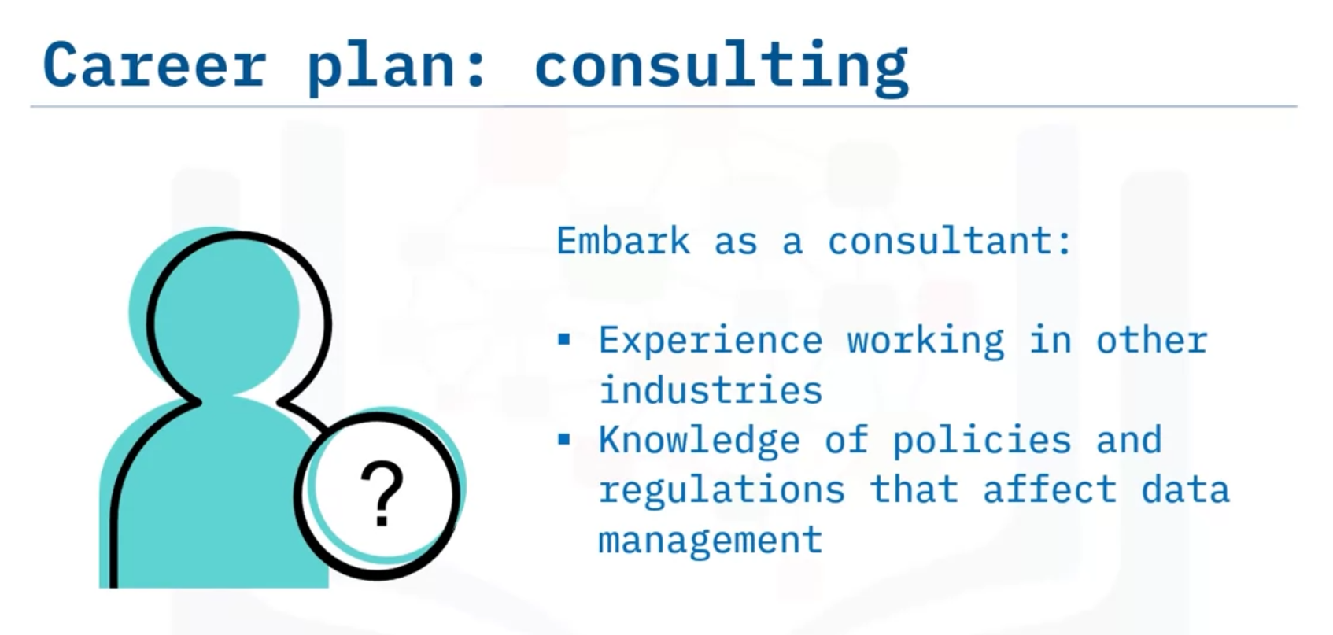

Sometimes a career path takes you deeper into the specialized knowledge of a specific discipline in data analytics, such as:

* Social media analytics
* Insurance and actuarial data analysis
* And fraud, credit, or sales analysis.

If you have a love or aptitude for one of these areas, it can be a great idea to dive into it and become the go-to professional in that discipline.

You may choose to progress into a senior role, building your toolkit as time goes by. This requires gaining more skills and developing the skills you have, including:

* Acquiring programming skills
* Learning more advanced mathematics
* And developing an understanding of many aspects of data science, such as AI and machine learning models, big data work, and others.

Rather than diving deeper as a specialist, the senior data analyst works to broaden and grow many skills.

If you’re interested in business, you may advance into a management position. This requires business aptitude and people skills as well as data analysis skills. Data analysis managers make a significantly higher salary, however. If this is your goal, you may want to:

* Focus on developing leadership and other people skills
* Acquire project management skills
* And consider acquiring a graduate degree or certifications in project management.

Management isn’t for everyone, but it may a good fit for you if you like the required mix of skills and work.

If you become a consultant, you can choose exactly what type of data expertise you want to develop. Since you are likely to be an independent worker, you may have some freedom about the situations you choose to work in. Consultants may want to:

* Develop experience working in the data-driven aspects of specific industries
* Acquire knowledge of policies and regulations that affect data management, such as customer privacy and data-collection protocols
* And understand the basics of running your own business.

Consultancy can be a great path if you want to design your own career, with all the freedom and risk that may entail.

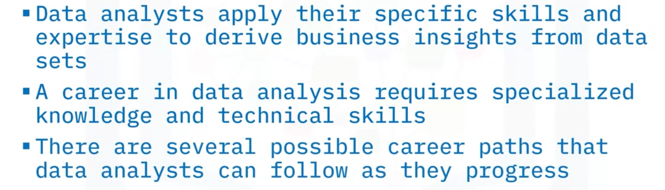

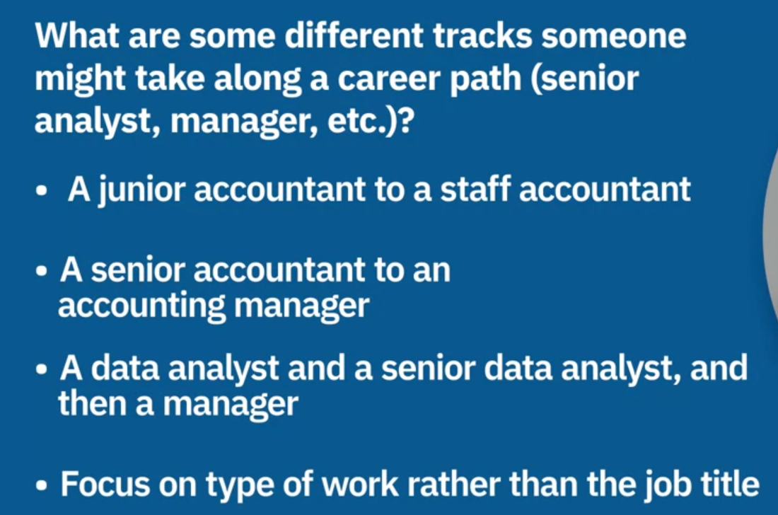



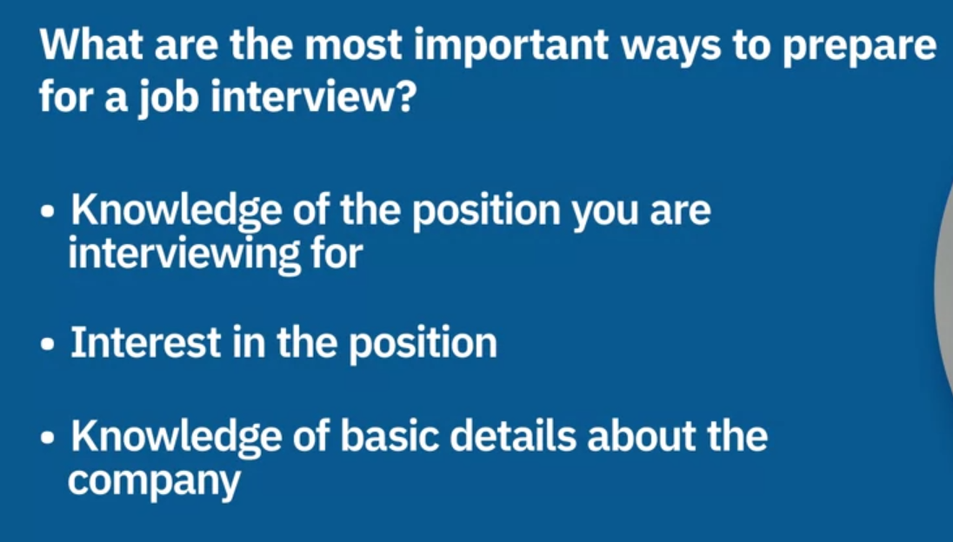

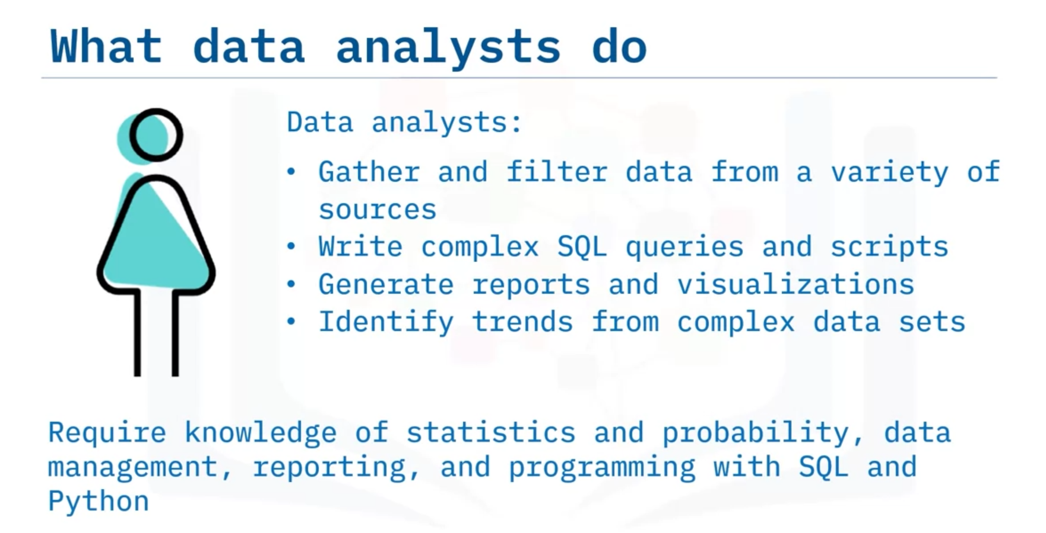

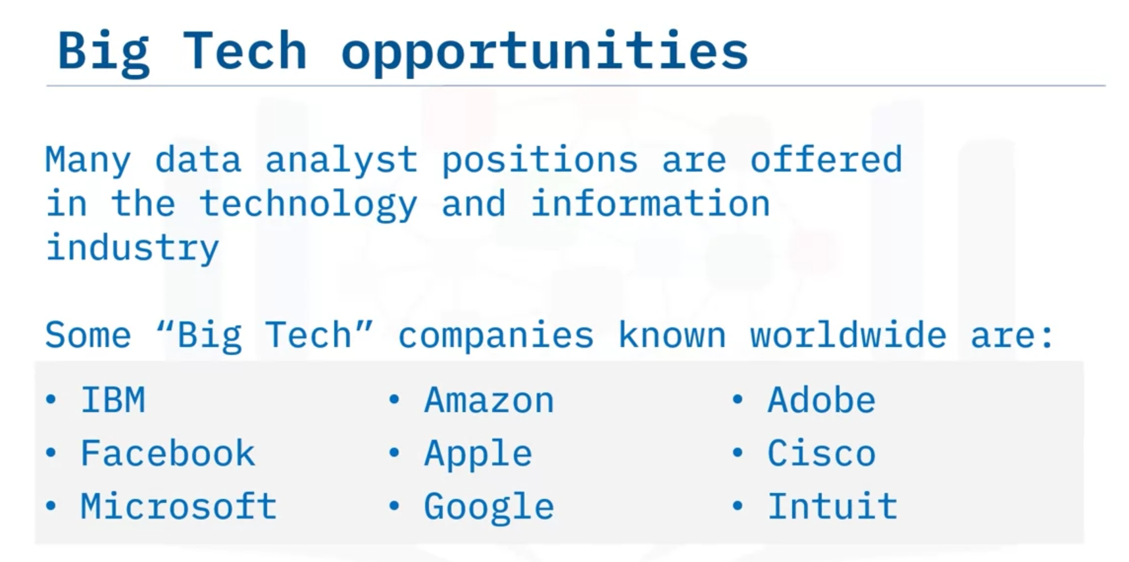

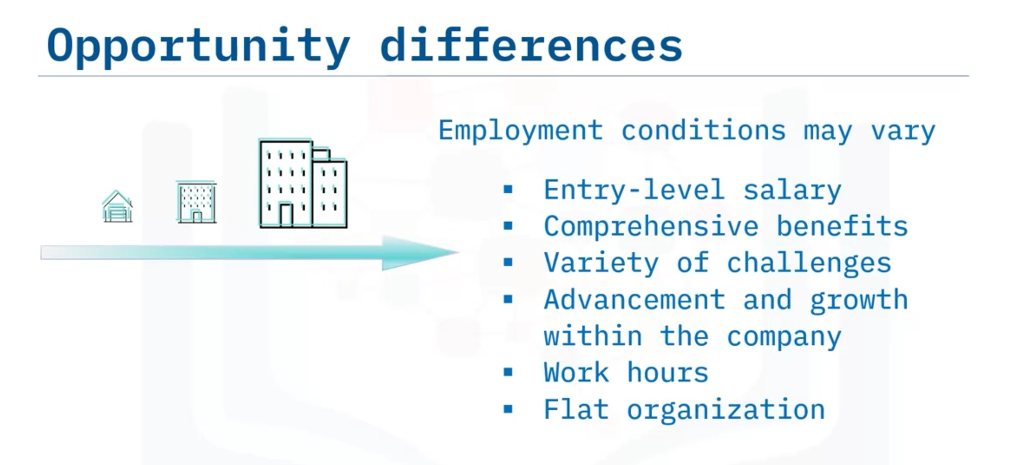

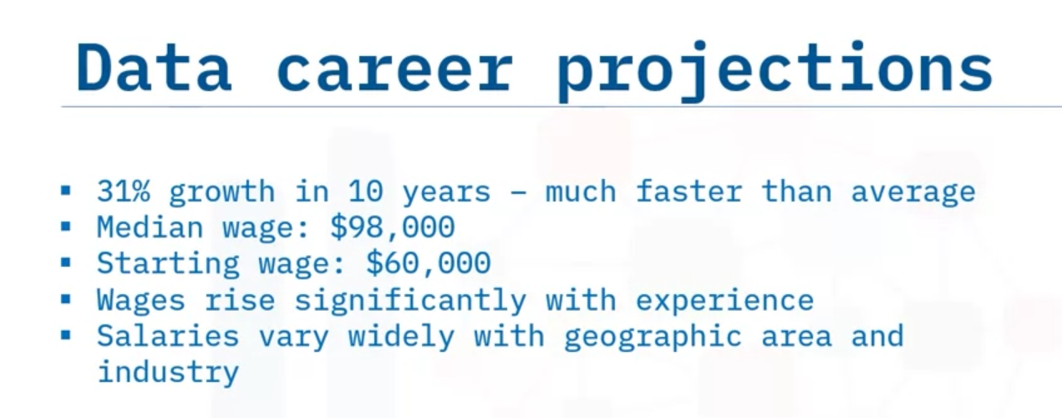

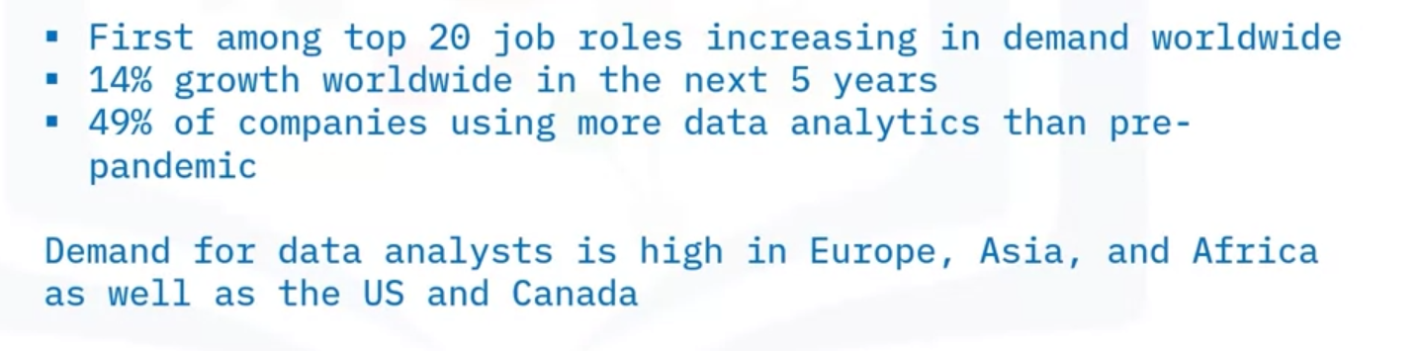

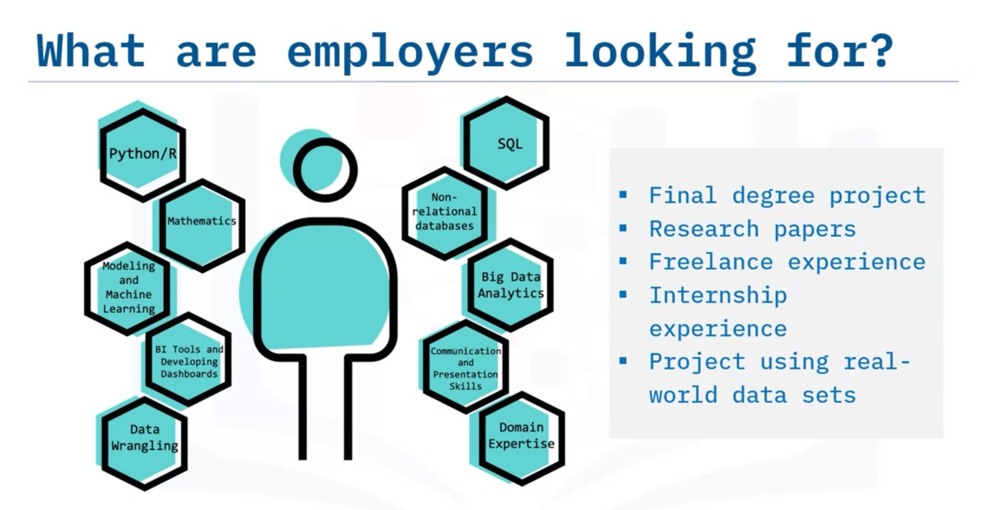

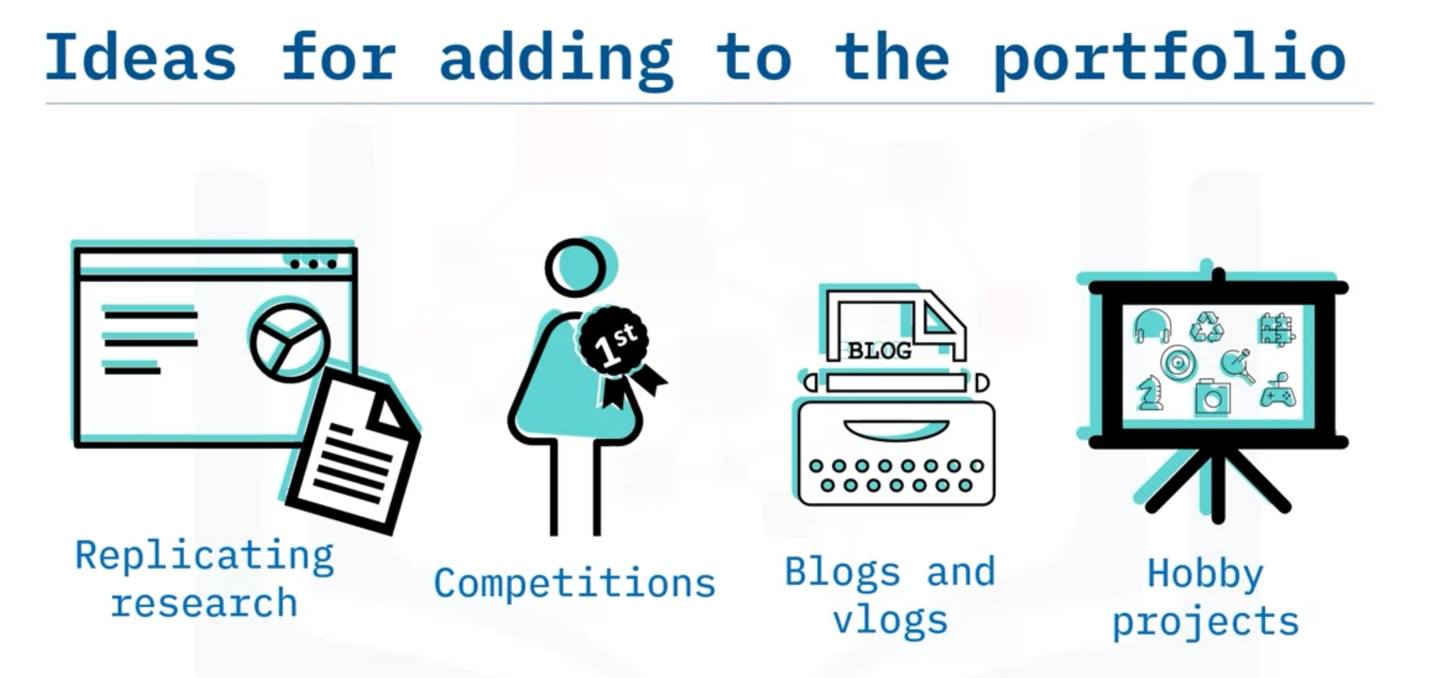

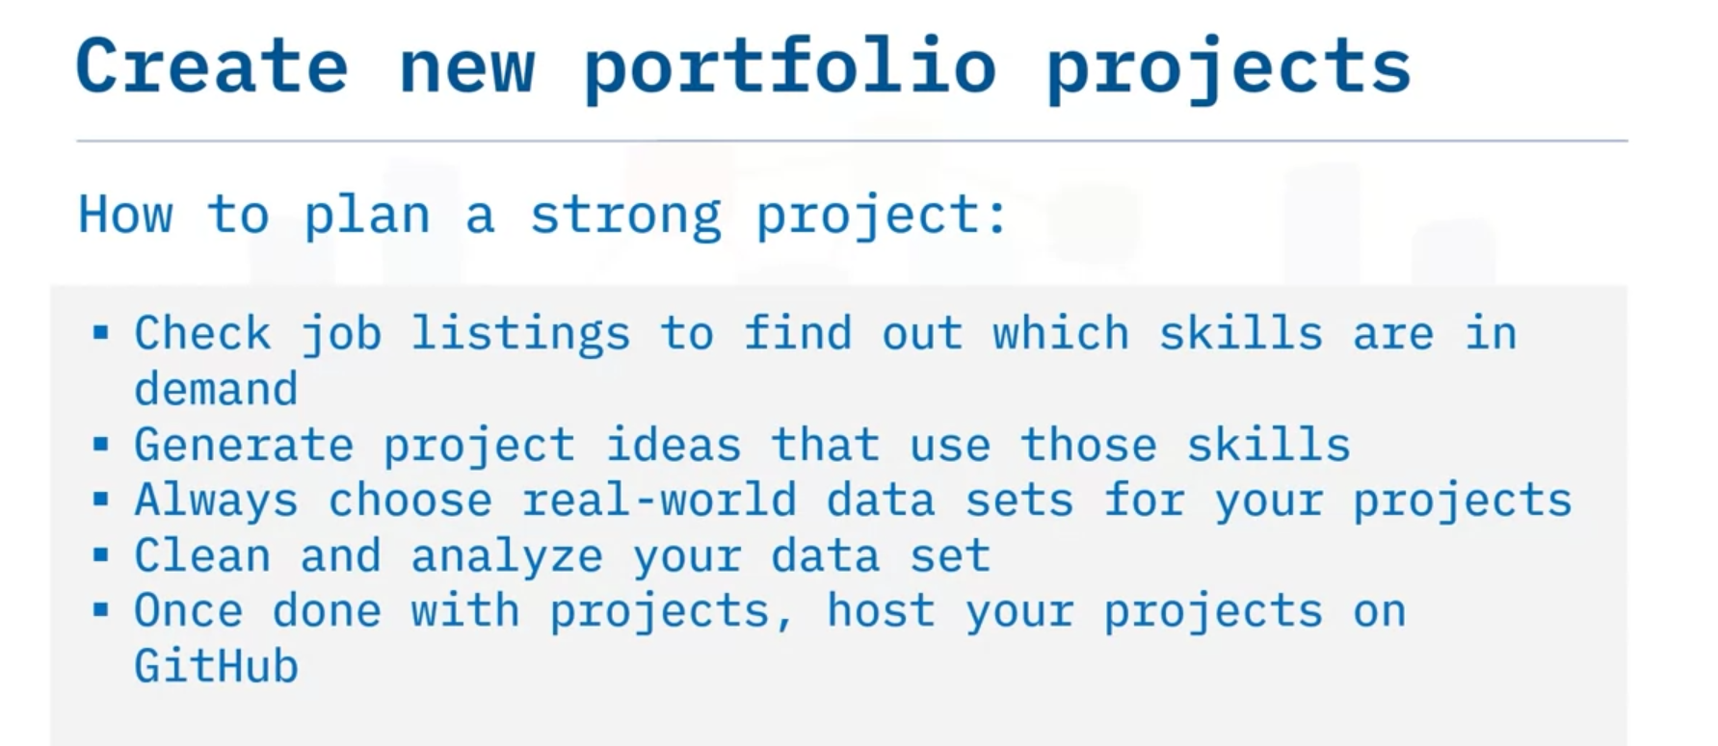



Sources of free data:

* Check online repositories that offer free and open access to enormous amounts of public data. Some useful resources include Data.gov, Reddit Datasets, GitHub’s Awesome Data, and Google Dataset Search.

